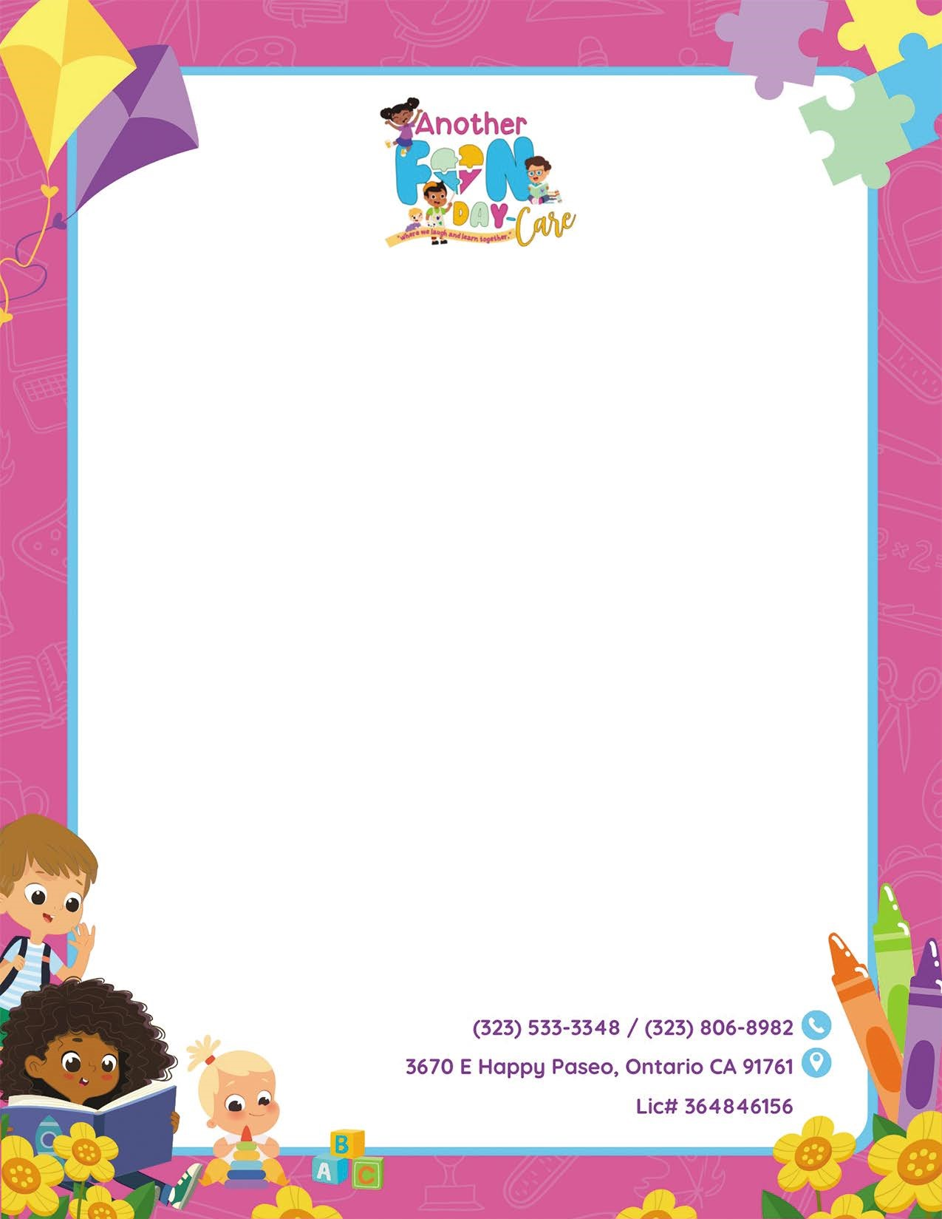
Another Fun Day-Care will observe the following Holiday’s for 2025 (Paid Holidays)
Dr. King Day (Jan 20)
President's Day (Feb 17)
Spring Break (March 5-11)
Memorial Day (May 26)
Juneteenth (June 19-20)
Independence Day (July 4)
Labor Day (Sept 1)
Veterans Day (Nov 11)
Thanksgiving (Nov 27-28)
Christmas (Dec 24 (Half Day)(25th Closed)
2025/2026 New Year’s (Dec 29-Jan 2)

* Tuition is still due during all holidays and vacations
*Any holiday where daycare is needed the daily rate will be assessed.

